**Overview**

The developed system is a proof-of-concept for the linear actuator control with real-time position, speed and force reading.

**Electronic diagram**

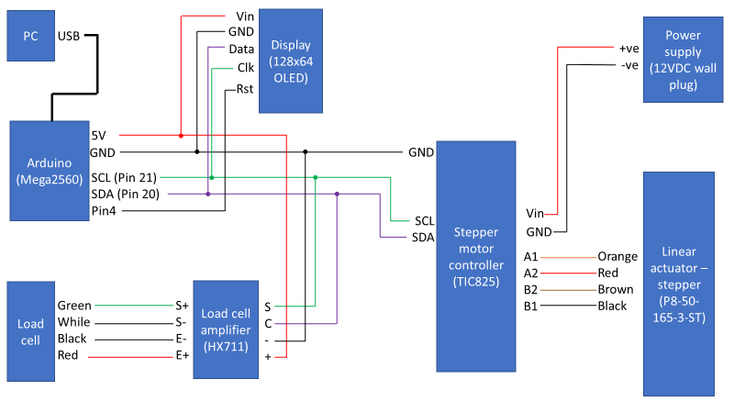

**Software**

Arduino libraries

1. Download the ‘QUT breast durometer project’ folder using this link <https://drive.google.com/drive/folders/1xMRb2B0T087dHZ2AB0OEE3ksbDsEuC1r?usp=share_link>
2. Go to ‘Arduino libraries’ folder.
3. Copy ‘libraries’ folder.
4. Open ‘Documents’ 🡪 ‘Arduino’ and paste.
5. If ‘Arduino’ folder doesn’t exist, create a new folder and call it ‘Arduino’.

Simple operation

1. Open Final program.ino
2. Go to line 35 and change ‘targetPosition’ variable to desired target position.
3. Go to line 36 and change ‘speed’ variable to desired speed.
4. Upload the code to Arduino.
5. The program will be executed as soon as it is uploaded.

For more comments/details refer to the “final program.ino”.